CRITERIA FOR THEME ONE CAPITAL PROJECTS

DONEGAL PEACEPLUS Plan

The overall objective of the total PEACEPLUS Programme is to build peace and prosperity and ensure that the PEACEPLUS Programme will leave a lasting and tangible legacy. The overall Programme’s strategy is to continue to take the opportunities and address the needs arising from the peace process to stimulate social and economic regeneration and promote social inclusion, particularly for those at the margins of economic and social life.

The combination of the PEACE and INTERREG type activities in a single programme is reflected in the name of the programme where “PLUS” represents the inclusion of wider economic, social, and environmental activities.

The following strands set by SEUPB for the thematic area 1.1, localised community PEACE action plans, will guide the design of the local PEACEPLUS Action Plan for Donegal namely:

(i) Local community regeneration and transformation
(ii) Thriving and peaceful communities
(iii) Celebrating cultures and diversity

These thematic strands provide scope to incorporate projects which span a range of different sectors and activities.

A Donegal PEACEPLUS Partnership has been established to oversee the design and implementation of the co-designed PEACEPLUS Action Plan in association with Donegal County Council.

As part of the co-design process so far there has been two stages of identifying issues and co-design concepts. This has resulted in a number of potential Theme One capital projects submitting concepts and a range of Theme Two and Theme Three opportunities being identified. As a result, the Partnership is further engaging with interested parties as part of stage three consultation to take the co-design process to the final stage before the Donegal PEACEPLUS Plan is submitted to SEUPB addressing all three programme themes.

Projects were invited to a further workshop to discuss the next stage for capital projects. The process for Theme One projects will be different to other Themes given the issues to be addressed in the delivery of capital projects and the timeframe involved.

Co Design Process

The co-design process is intended to:

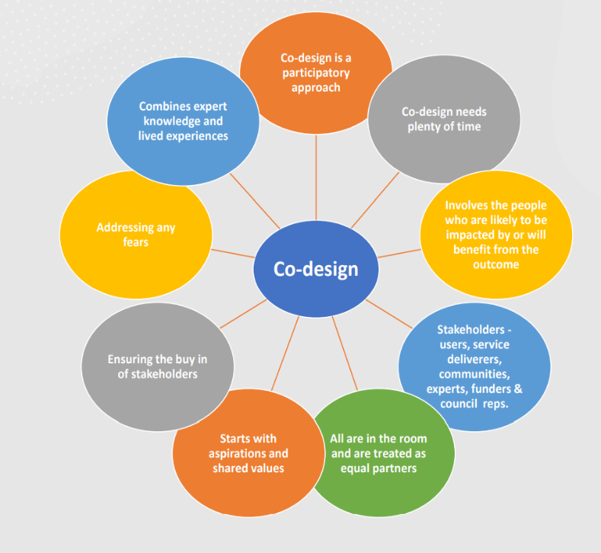
- Facilitate the Partnership and Council in the need to ensure local level involvement in developing the PEACEPLUS Plan;

- Help align the final PEACEPLUS Plan with the objectives of the PEACEPLUS Programme;

- Enable greater cross community engagement and collaboration;

- Enable groups which represent different communities of interest from defined areas or themes, to collaboratively assist in the design process of the Plan;

- Ensure priority projects are tailored to meet the challenges and opportunities specific to their area.

The co-design process in the two stages to date have included:

Criteria generally in the PEACEPLUS Programme also applied to capital projects and were identified early to participants as including:

- Contribution of the project to the PEACEPLUS Programme and the Investment Area (Specific Objective), including to defined results and outputs of the Programme
- Quality of the project design. Need, demand and strategic alignment
- Readiness to deliver
- Quality of cross community co-operation with demonstratable added value
- Contribution to Sustainable Development
- Equality and Accessibility
- Value for Money

Please note the outcomes for Theme One: Local Community Regeneration & Transformation outlined below should also be considered in your response. This includes to:

- Empower local people to regenerate and transform communities on a cross community basis
- Change how people feel about their local area.
- Change how people use their local area.
- Visually reflect the character and shared heritage of an area
- Redress poverty, inequalities and disadvantage
- Make lasting improvements to their local area
- Prioritise the most marginalised and vulnerable communities
- Create pathways for increased levels of cross community interaction

Next Steps Theme One/Capital Projects

Those submitting concept forms were invited to an initial stage three workshop to discuss the next steps and participate in further co-design for Themes Two and Three; and for Theme One/capital to be provided with information on the submission process including criteria.

Theme One projects are asked to make a submission, which will then be assessed by a working group of the Partnership. That working group will meet to discuss the submissions and make a recommendation to the full Partnership on the 22nd of November 2023.

This application process should be carried out mindful of the requirements of the PEACEPLUS Programme and the consultation work to date undertaken by Donegal PEACEPLUS Partnership as part of the PEACEPLUS co-design process. Information can be access through the following websites and pages and queries may be made to the PEACEPLUS Team in Donegal at: PEACE@Donegalcoco.ie

Investment Area 1.1 - Co-designed Local PEACEPLUS Action Plans | SEUPB

Donegal County Council (donegalcoco.ie)

Based on consultation and demand including Stage One to Three workshops and the submission of 82 concept forms, after administration costs of c.20% has been set aside, the Donegal PEACEPLUS Partnership have agreed an indicative allocation for Theme One of c. €2.4 million to be allocated equally across all five Municipal Districts. This allocation is considered by the Partnership to be a reasonable reflection of need and demand in each MD taking in to account issues of demography, isolation, and issues reflecting rural and urban needs.

Completion and Submission of Applications

All documents should be completed and returned as directed.

1. Applicants must submit their applications by 5pm on 6th November 2023

- Late applications will not be considered.

- Applications received other than by email will not be considered.

- Irish language application will be available on our webpage.

- Applications must be compliant with the requirements detailed in the quotation documentation. No amendments to the documents should be made by applicants. If applicants still consider modifications to be necessary, these should be detailed separately in their response.

- Donegal PEACEPLUS Partnership is not obliged to consider or accept alternative applications. Similarly, applications made subject to additional or alternative Conditions of Contract may be rejected.

- Applications may also be rejected if the complete information is not given when requested.

- All requests for clarification or further information in respect of this application or any questions about the process, should be submitted in a timely fashion. All queries should be submitted to Peace@DonegalCoCo.ie by 5pm on 30th October 2023.

The indicative timetable is as follows:

No. | Activity | Date
1 | Issuing of application documents | w/s 21st August 2023
2 | Submission of applications | 6 th November 2023
3 | Assessment of applications submitted by working group of DCC PEACEPLUS Partnership | w/s 2nd November 2023
4 | Ratification by PEACEPLUS Partnership | 22nd November 2023
5 | Submission of PEACEPLUS Action Plan | No later than 14th December 2023
6 | DCC undertakes process to identify appropriate contractor and manage capital works | From Spring 2024 onwards
DCC PEACEPLUS Partnership and Council reserve the right to amend these timelines if necessary.

The applications for assessment issued for Theme One/Capital, includes the following background:

- The allocation of resource (indicatively agreed by the Partnership as c. €2.44m for Theme One) will be allocated equally across all MDs suggesting a maximum spend in each MD of approximately €500k. Those responding should budget accordingly.
- Some discretion may apply to utilise all of the budget depending on what is supported in each MD.
- All concept idea submissions and organisations will continue to be welcome to contribute to the co-design process for Themes Two and Three.
- This will be a competitive process so there should be no lobbying of Partnership Members, Council staff or Councillors.

It was agreed at the last Partnership meeting that Donegal County Council will be the lead partner under 1.1 Investment Area 1.1 Co-designed Local Community Peace Action Plan for Donegal. As such Donegal County Council will be the budget holder in theme One; Council will be responsible for any works completed, with the associated Partner.

The criteria, as agreed by the Partnership, will be the basis of Theme One of the Peace Plan.

Selection Criteria: Local Community Regeneration and Transformation

The application must contain sufficient information for a robust assessment to be carried out. The applicant must ensure that the application is fully complete at the time of submission. There will be no opportunity for the applicant to further develop their project other than responding to specific points of clarification which are considered fundamental. This ensures that there is an open, fair, equitable and transparent process during the assessment of the application.

The applications will be scored (0-5) against the following criteria which weighted as listed below.

Criterion | Weighting | Total Score Available
Contribution of the project to the PEACEPLUS Programme and the Investment Area (Specific Objective), including to defined results and outputs of the Programme | 4 | 20
Quality of the project Design- Need, Demand and Strategic Alignment | 4 | 20
Readiness to deliver | 3 | 15
Quality of cross community co-operation with demonstratable added value | 2 | 10
Contribution to Sustainable Development | 2 | 10
Equality and Accessibility | 2 | 10
Value for Money | 3 | 15
Total |  | 100

Scoring and quality threshold

Each application will be and awarded a score between 0-5 for each criterion. This is based on a pre-determined rating system depending on how well the evidence provided by the applicant satisfies the assessment questions.
Score | Assessment | Indicator
0 | Nil Response | Response failed to address the question
1 | Very Poor | A very poor response with limited evidence of capacity to deliver against the criterion.
2 | Poor | A poor response with some evidence of capacity to deliver against the criterion, but overall, it is below the standard expected for an award of funding.
3 | Acceptable | A sound response which demonstrates evidence of the capacity to deliver to an acceptable standard against the criterion but does not demonstrate any added value in delivery above the minimum standard required
4 | Good | A very good response with strong evidence of capacity to deliver above the minimum standard expected against the criterion.
5 | Excellent | An excellent response with very strong evidence of capacity to deliver well above the minimum standard expected against the criterion demonstrating considerable knowledge and experience

Criterion CAPITAL PROJECTS | What it means | Score | Weighting (indicative)
Contribution of the project to the PEACEPLUS Programme and the Investment Area (Specific Objective) including forward usage and defined results and outputs of the Programme | CAPITAL PROJECTS  Criteria to include:  - Assessment of how the project, once completed, will add value to PEACEPLUS outcomes e.g. who, when, how many people will use the project as a result of the changes, and for what purpose?  - Whether the proposed project might lead to sustained contact between different religions, ethnic, cultural and political backgrounds or with cross border communities, and how might that happen?  - Whether the project concept can lead to a tangible and lasting contribution to peace and reconciliation?  - Whether the project concept contributes to building strong relationships and connections?  - Whether the project leads to the sustained inclusion of people from different backgrounds?  - The project design is rational and likely to deliver the outputs and outcomes set?  • Are Peace and Prosperity core elements to the project objectives and outcomes?  - Does it target appropriate beneficiaries/stakeholders?
Quality of the project Design Need, Demand and Strategic Alignment | CAPITAL PROJECTS  Criteria to include:  - Is the project design of good quality?  - Does the project align with existing national / local strategies including the LECP?  - Is there funding for this project from any other source within or outside the council?  - Does the project concept build on the success of previous PEACE projects?  - Is there a demonstrated need for the project? Is the project filling a gap in evidence, services, provision?  - Does the project concept target disadvantaged and include marginalised communities and PEACEPLUS target groups?  - Are the target beneficiaries clearly defined and relevant to the objectives of your proposal ?  - Has the project concept considered displacement ?  - Is the project inclusive of a range of groups and stakeholders?
Readiness & Delivery | CAPITAL PROJECTS  Criteria to include:  - There is clear, professionally agreed cost estimates for any works to be completed.  - There is planning permission for the proposed project in place or a process outlined for its timely acquisition?(if required)  - The necessary consents, permissions, ownership and statutory approvals are in place or a process outlined for their timely acquisition?(if required)  - Land/ property ownership / lease status is identified, and permissions received from the property owner if different from the project promoter?
Quality of cross community co-operation with demonstratable added value | CAPITAL PROJECTS  Criteria to include:  - Does the proposed project include or have the opportunity for collaborative cross community and/or cross border partnership/s or activity/ies?  - If a single identity concept initially, working for instance with lower capacity groups, does the project concept lead to sustained contact between different religions, cultural and political backgrounds or with cross border communities?  - Is the project concept targeted and transformative in a way that could bring about positive change in communities?  - Does the project concept lead to a tangible and lasting contribution to peace and reconciliation?  - Does the project concept contribute to building strong relationships and connections?  - Can the project concept lead to the sustained inclusion of people from different backgrounds leading to a sense of belonging and a strong community spirit?  - Can the project concept lead to inclusive respectful and resilient communities?
Sustainability | CAPITAL PROJECTS  Criteria to include:  Projects are expected to show how they will make a contribution to sustainable development.  - Assessment of additional cost beyond the lifetime of the capital funding and how it may be met e.g. costs such as insurance, updating equipment and refurbishment?  - Commitment to opportunities for good environmental building standards e.g. energy/CO2; water; materials; surface water runoff (flooding and flood prevention); waste; pollution; health and well-being; management; and ecology?  - Identification of positive or negative environmental effects related to the proposed project ?  - Potential climate change impacts?  - Alignment with UN Sustainable Development Goals? Annex 1
Equality and Accessibility | CAPITAL PROJECTS  Criteria to include:  - The project makes a positive contribution to the principles of equal opportunities, non-discrimination and good relations in respect of religious belief, political opinion, gender, race, disability, age, marital status, dependents and sexual orientation?  - The project makes a positive contribution to the principle of equality between men and women, gender mainstreaming and the integration of a gender perspective?  - Whether a similar project has been funded in the area by PEACE before?  - Contribution to physical, social and economic regeneration?  - Whether the project concept offer opportunities for different equality groups / rural and urban / PEACEPLUS target groups to be engaged?
Value for Money | CAPITAL PROJECTS  Criteria to include:  - Whether there is funding for this project concept from any other source within or outside the Council?  - Whether there is any displacement?  - Cost and value?  - Usage numbers anticipated relative to cost?  - Is the budget proportionate to the outputs being delivered?  - Have financial assumptions and a breakdown of costs been provided?  - Are costs clear and realistic? Are costs per year/period in line with project and Programme dynamics? Do costs align with sourcing constraints and match the level of available skills required for successful delivery?  - Where a project wishes to argue for social or environmental value (in cases where costs may seem out of line with anticipated market value), have they made evidence and justification clear?  - Does the budget include only necessary costs required to complete the outputs and results?
 |  |  | Out of 100

Annex 1 : United Nations Sustainable Development Goals

- End poverty in all its forms everywhere
- End hunger, achieve food security and improved nutrition and promote sustainable agriculture
- Ensure healthy lives and promote well-being for all at all ages
- Ensure inclusive and equitable quality education and promote lifelong learning opportunities for all
- Achieve gender equality and empower all women and girls
- Ensure availability and sustainable management of water and sanitation for all
- Ensure access to affordable, reliable, sustainable and modern energy for all
- Promote sustained, inclusive and sustainable economic growth, full and productive employment and decent work for all
- Build resilient infrastructure, promote inclusive and sustainable industrialization and foster innovation
- Reduce inequality within and among countries
- Make cities and human settlements inclusive, safe, resilient and sustainable
- Ensure sustainable consumption and production patterns
- Take urgent action to combat climate change and its impacts
- Conserve and sustainably use the oceans, seas and marine resources for sustainable development
- Protect, restore and promote sustainable use of terrestrial ecosystems, sustainably manage forests, combat desertification, and halt, and reverse land degradation and halt biodiversity loss
- Promote peaceful and inclusive societies for sustainable development, provide access to justice for all and build effective, accountable, and inclusive institutions at all levels
17. Strengthen the means of implementation and revitalize the Global Partnership for Sustainable Development

